EXP-3
E- Commerce Mobile App Prototype (Figma)
Aim
To design a prototype for stakeholder feedback.
Procedure
1. Create mobile frame in Figma.
2. Design Home, Product Page, Cart, Checkout.
3. Create two UI variations (to resolve conflict).
4. Present to stakeholders for feedback.
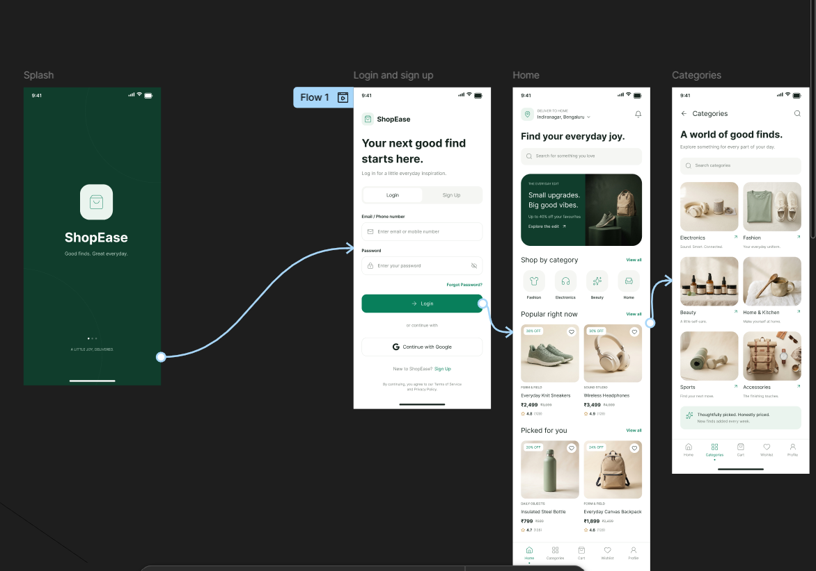

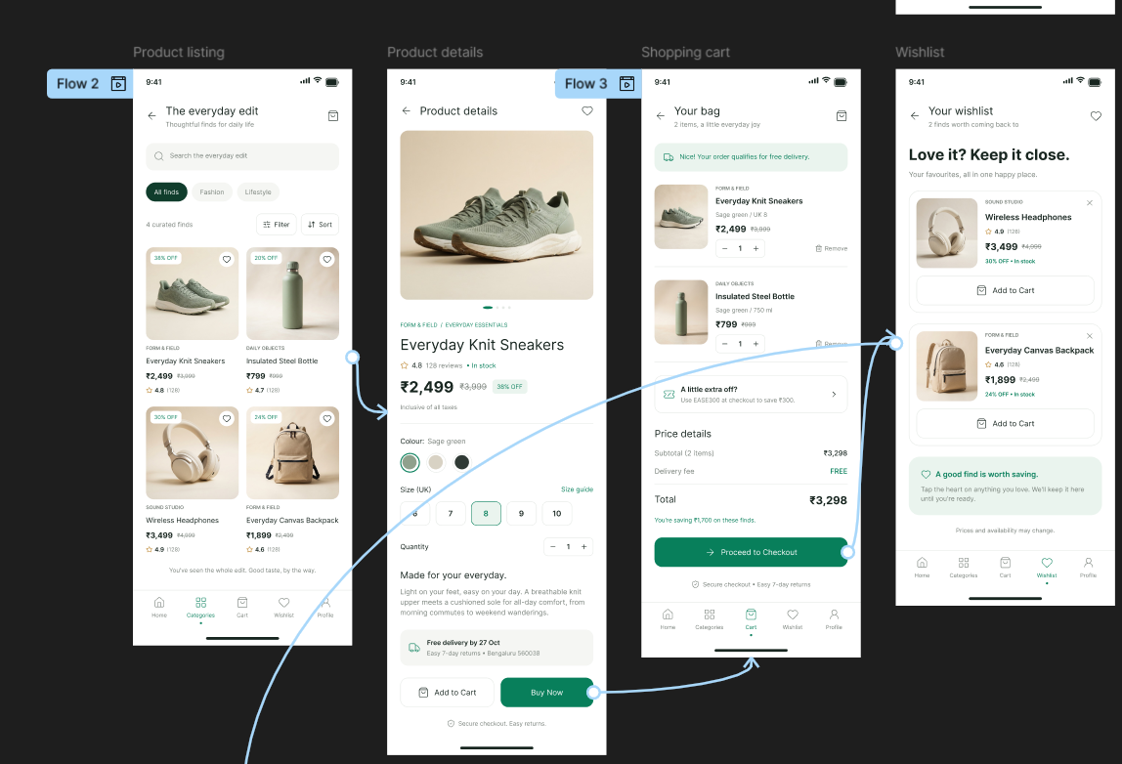
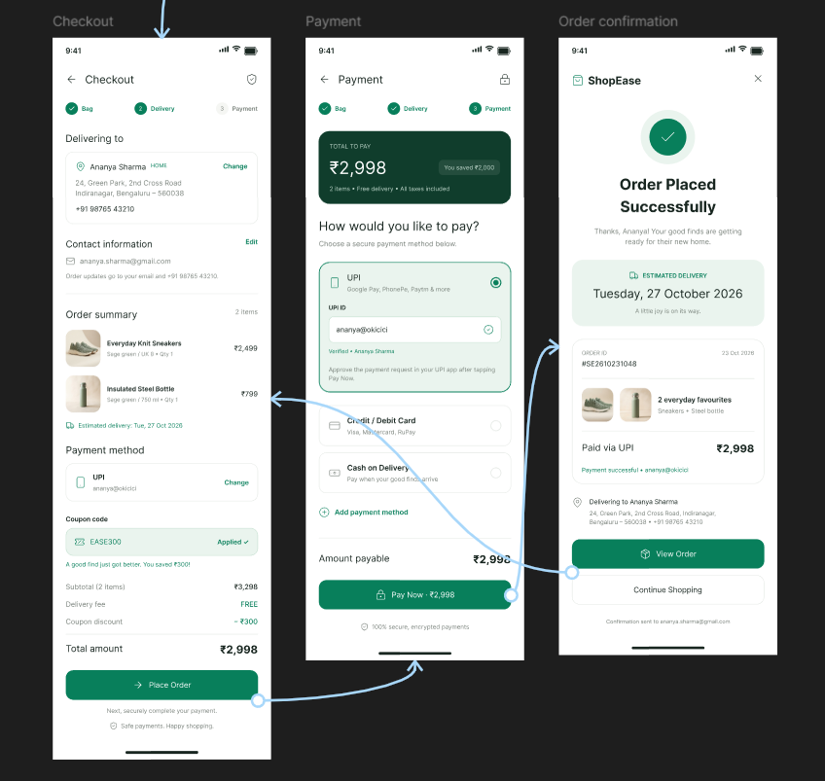
Result: Thus, The Prototype created and stakeholder feedback collected for
UI finalization.

